# README FILE

**Products: Soil Moisture Maps**

**Data used: Sentinel-1 (SAR- radar sensor) and Sentinel-2 (optical sensor)**

**Scale: Plot scale**

**Site: Authion, France**

The soil moisture maps were carried out at a plot scale. A map is provided each 6 days (12 days with Sentinel-1A and 12 days with Sentinel-1B) for the period between September 2017 and August 2019.

Inversion algorithm for estimating soil moisture was applied for agricultural areas with any vegetation cover.

The land cover map provided by Jordi Inglada et al (Cesbio, Theia) was used as well as Sentinel-2 images corrected for atmospheric effects. The Land cover map was used to extract the agricultural areas. Sentinel-2 images were used to calculate the NDVI (Normalized Differential Vegetation Index) and to segment the agricultural areas in order to extract homogeneous polygons within agricultural plots.

Using several in situ measurements of soil moisture, the accuracy on soil moisture estimation was evaluated to be about 6 vol.

NDVI maps are provided in the folder named “NDVI”. For each Sentinel-1 acquisition date a corresponding NDVI map was used in producing the soil moisture map:

|  |  |
| --- | --- |
| **Sentinel-1 acquisition date** | **NDVI map used** |
| September - October 2017 | NDVI October 2017 |
| November – December 2017 | NDVI November 2017 |
| January 2018 | NDVI January 2018 |
| February 2018 | NDVI February 2018 |
| March 2018 | NDVI March 2018 |
| April 2018 | NDVI April 2018 |
| May 2018 | NDVI May 2018 |
| June 2018 | NDVI June 2018 |
| July 2018 | NDVI July 2018 |
| August 2018 | NDVI August 2018 |
| September 2018 | NDVI September 2018 |
| October 2018 | NDVI October 2018 |
| November 2018 | NDVI November 2018 |
| December 2018 | NDVI December 2018 |
| January 2019 | NDVI January 2019 |
| February 2019 | NDVI February 2019 |
| March 2019 | NDVI March 2019 |
| April 2019 | NDVI April 2019 |
| May 2019 | NDVI May 2019 |
| June 2019 | NDVI June 2019 |
| July 2019 | NDVI July 2019 |
| August 2019 | NDVI August 2019 |





## Deliverable description

The Soil Moisture Maps are divided into two main folders:

* S1A: referring to maps derived from Sentinel 1A satellite

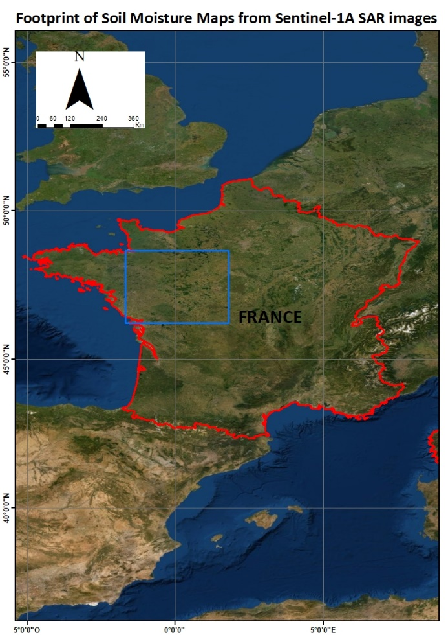To see the location of S1A surface soil moisture map please refer to the provided map “Footprint_S1A (.JPEG)” in folder S1A.

* S1B: referring to maps derived from Sentinel 1B Satellite

To see the location of S1B surface soil moisture map please refer to the provided map “Footprint_S1B (.JPEG)” in folder S1B.

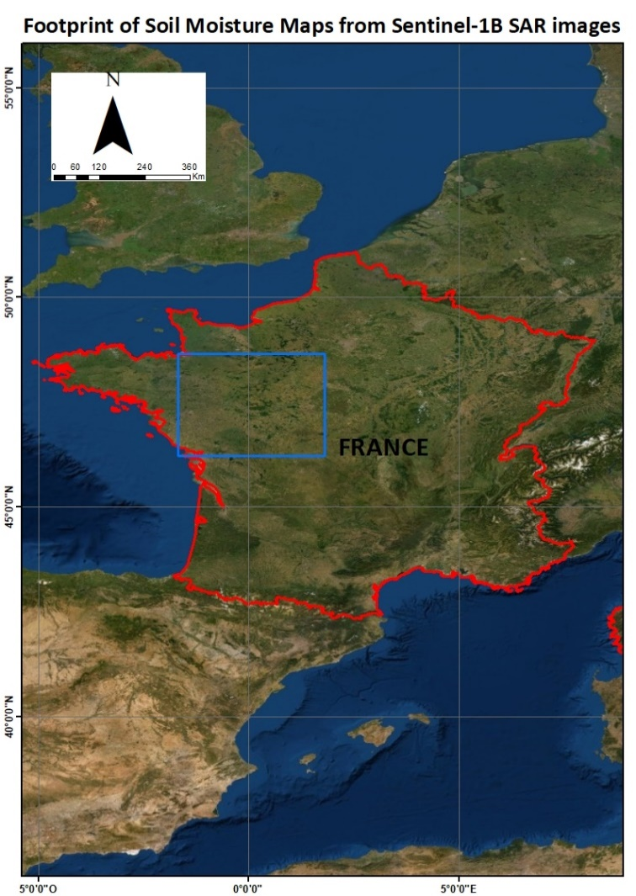

## Format:

Format description of soil moisture maps (for example 20160904T173856_ mv.tif):

* GeoTIFF
* Structure of files name: yyyymmddThhmmss_mv.tif
* yyyy:year
* mm: month
* dd: acquisition day

T is used to separate the date and the time (UTC)

* hh: hour
* mm: minutes
* ss: seconds

## Important:

1. In the provided soil moisture maps (WGS84, EPSG: 4326), the soil moisture values (*mv*) are multiplied by ***5*.** In order to derive the estimated soil moisture value from the provided maps ***it is necessary to divide*** by ***5***.
$$Soil Moisture Estimation \left(mv Vol.\%\right)= \frac{Value obtained from the Map}{5}$$

2. In the provided NDVI maps (NDVI folder, Geotiff format), the NDVI values are multiplied by ***100***. To derive the NDVI value from the maps ***it is necessary to divide*** the obtained value by ***100.***
$$NDVI = \frac{Value obtained from the Map}{100}$$

3. Null values in the soil moisture maps = no data (no soil moisture estimation)

**Nicolas Baghdadi, Mohammad El Hajj, Hassan Bazzi, Micheal A. Arhinful**

**Avec la collaboration de Mehrez Zribi (Cesbio)**

**Irstea, TETIS, Montpellier**

|  |  |  |  |
| --- | --- | --- | --- |
|  |  |  |  |